SAHIR SHOUKAT
Creative Designer • Content Writer • Video Editor • Social Media Management
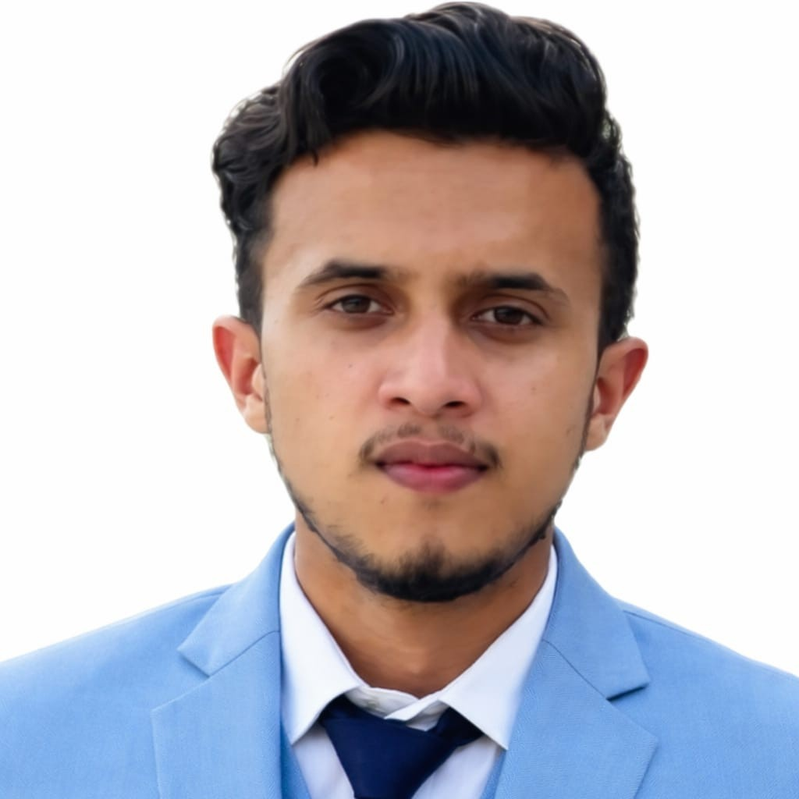
CONTACT
0337 9860189 | 0316 8860189 | sahirshoukat01@gmail.com | Mirpur, AJK
LinkedIn: https://www.linkedin.com/in/sahir-shoukat-78b3a3363
PROFILE
BS Computer Science student at Mirpur University of Science & Technology (MUST), with a strong interest in creative digital work and technology. Skilled in graphic design, content writing, video editing and social media management, with practical experience using Canva and Photoshop. A motivated learner seeking opportunities to build professional experience and contribute to creative and technology-focused projects.
EDUCATION
BS Computer Science — Mirpur University of Science & Technology (MUST) | In Progress • Semester 6 • Expected 2027
Intermediate — Modern Public School & College | 770 / 1100 marks
Matriculation — Central Public School Datote Pachiot, Rawalakot, AJK | 2021 • 897 / 1100 marks
CORE SKILLS
Graphic Design • Content Writing • Video Editing • Social Media Management • Canva • Adobe Photoshop • Creative Content Development • Computer Science Fundamentals
PROJECTS
YOLOv8 Urdu Scene Text Detection & Recognition
AI/computer vision project focused on detecting Urdu scene text using YOLOv8, with dataset preparation, model training and visualization.
Web Development Projects
Developed academic web projects using front-end and server-side web technologies, with focus on practical layouts, forms and user interaction.
Student / Academic Software Projects
Worked on university programming and application-development assignments involving databases, interfaces and problem-solving.
LANGUAGES
Urdu — Native/Fluent | English — Good Working Proficiency
CAREER INTERESTS
Graphic Design • Content Creation • Social Media • Video Editing • Digital Marketing • Entry-Level IT / Creative Technology Roles

